Reviewer reports:  
  
**Reviewer #1:** *Colon cancer is the 3rd lethal malignancy in the world whose early detection would greatly benefit from the blood based measurements, and cell free DNA methylation abnormality has been proved to be one of the most promising biomarkers for early cancer diagnosis in multiple cancer types. In this study, Fan and co-workers identified some differentially methylated CpG sites by comparing DNA methylation profiles of pre-cancer adenoma specimens to normal colon tissue samples, and by integrating other public datasets, Fan and coauthors revealed DNA methylation at promoter of ADHFE1 is the most promising diagnostic biomarker. Overall, the manuscript is well written, and analysis is well done, and the whole study is likely to generate considerable interest in the field. However, some key questions need to be addressed before I make my further decision.*

**Overall response**: We thanks the reviewer for the encouraging comments. We have addressed the detailed questions below. We found these comments very valuable to us. By addressing these questions, we have significantly improved the presentation of our work, especially clarifying many points in the method and result sections. We really appreciate the encouraging comments from the reviewer.   
*“1. The authors profiled DNA methylation for 18 LGA, 22 HGA and 20 normal tissues, and found significant DNA methylation differences across them. Authors should provide a detailed QC metrics and DNA methylation correlation coefficient across samples within each tissue type to demonstrate the technique reproducibility and methylation homogeneity in each tissue type.”*

**Response:** Thank you for the suggestion. For the QC, we have added a new **Figure S8**, in which the density plots demonstrate relatively consistent distribution of beta values across all sample before and after normalization. According to the 10000 most variable positions, the multi-dimensional scaling plots show the homogeneity in each tissue type and these samples are clustered according to their pathological groups. In addition, we have also provided a **Figure S9** showing the results from the 1000 and 20000 most variable positions, which demonstrate similar tendency. Besides, we revised QC details in the part of Methods and a few additional statements was included in revised version. Basically, we tried first to ensure similar numbers of Normal, LGA and HGA samples on each array. We have updated these revisions in the method section with red labelling between line xx and line xx (page xx) and new added Figure S8 and Figure S9.

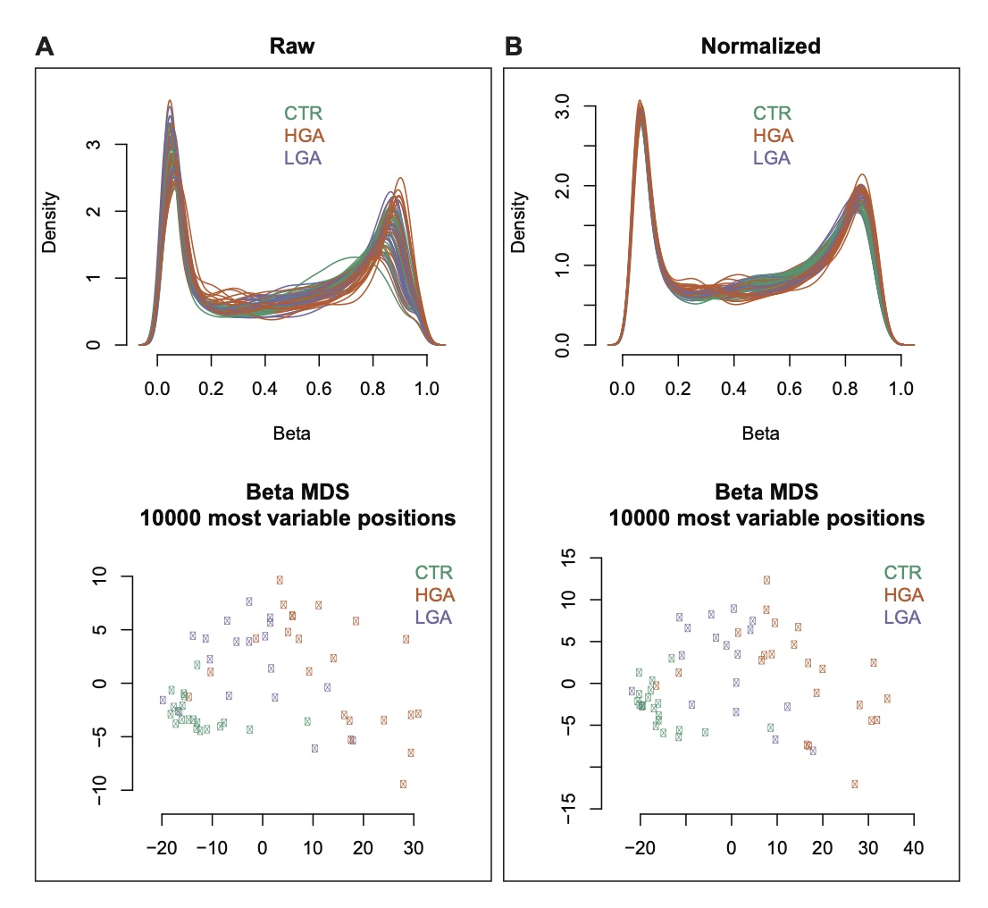

**Figure S8.** Density of all beta values (top panel) and multi-dimensional scaling (MDS) (bottom panel) according to 10000 most variable positions for samples in high grade adenoma (HGA), low grade adenoma (LGA) and normal tissue (CTR) before (A) and after (B) normalization. The density plots demonstrate relatively consistent distribution of beta values across all sample even before normalization. According to the 10000 most variable positions, the MDS plots show the samples clustering according to their pathological groups. Particularly, normal tissues (green dots) have high homogeneity, forming a dense cluster in the bottom left corner of the plot; and heterogeneity of samples increase from normal tissues, low-grade lesions (orange dots) to high-grade ones (purple dots), as sample dots having increased spacing from bottom left to top right.

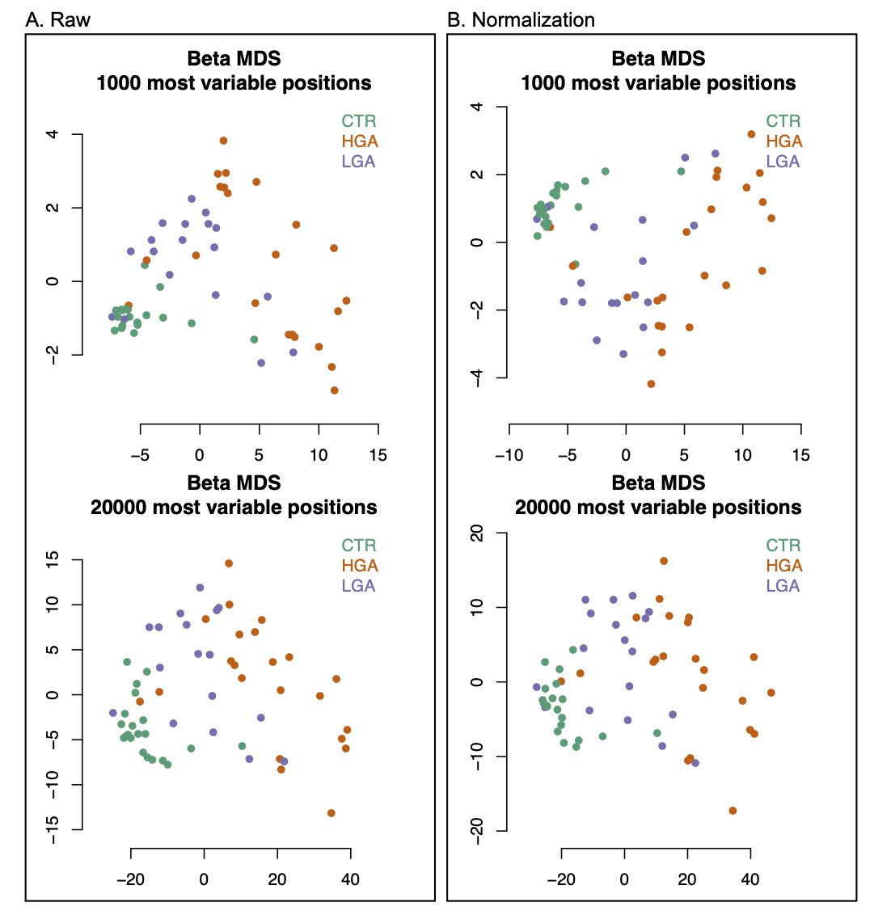

**Figure S9.** Multi-dimensional scaling (MDS) according to 1000 (Top panel) and 20000 (Bottom panel) most variable positions for samples in high grade adenoma (HGA), low grade adenoma (LGA) and normal tissue (CTR) before (**A**) and after (**B**) normalization.

*“2. Little information is provided for the therapy regimen for the patients whom the authors obtained specimens from. Different drugs may have different levels of effects in shaping the DNA methylation, or are they all treatment naïve?”*

**Response:** Thank you for your suggestion. We are sorry that we forgot to provide this information in the previous manuscript. In our revised version, a new table (**Table S6**) showing patient information has been included. All the patients were treatment naïve at the time of surgery.

*“3. This is a key point, since the authors identified some differentially methylation CpG sites and claimed some of the sites might be useful for early detection. The author should check the methylation status of these CpG sites in the blood samples from normal individuals from public databases. Without this data, the clinical utility and the sensitivity of their findings is questionable.”*

**Response:** Thank you for the important suggestion. Following reviewer’s comments, in our revised version, we included the details of the methylation values in our identified 209 hyper-methylated DMSs in LGA as a new Table (**Table S1**). In addition, we also checked the DNA methylation level of these 209 sites in 656 cases of human whole blood from GEO (accession number GSE40279) and plotted a heatmap as Figure S7 (shown in below). Indeed 207 out of 209 sites had low methylation level (< 0.3 in average methylation value), which was significantly lower from those in tumor and adenoma tissues. We also examined the DNA methylation level of *ADHFE1* promoter in these 656 cases of whole blood and low level of methylation at all the cases was observed in a new **Figure S6**.

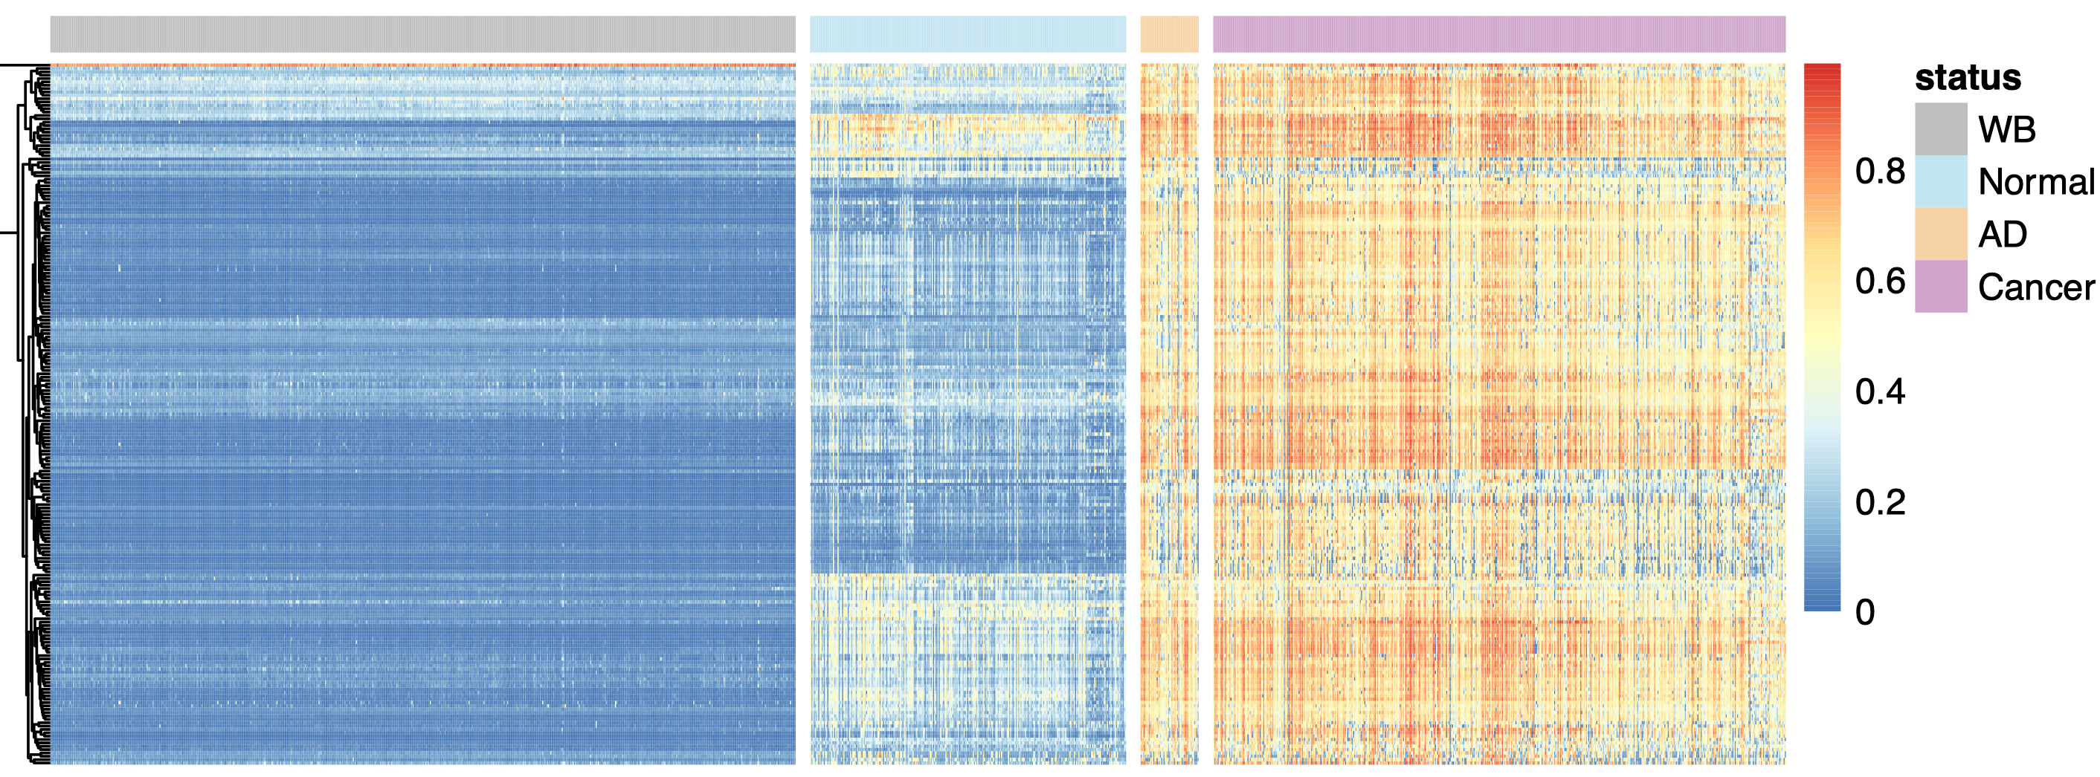 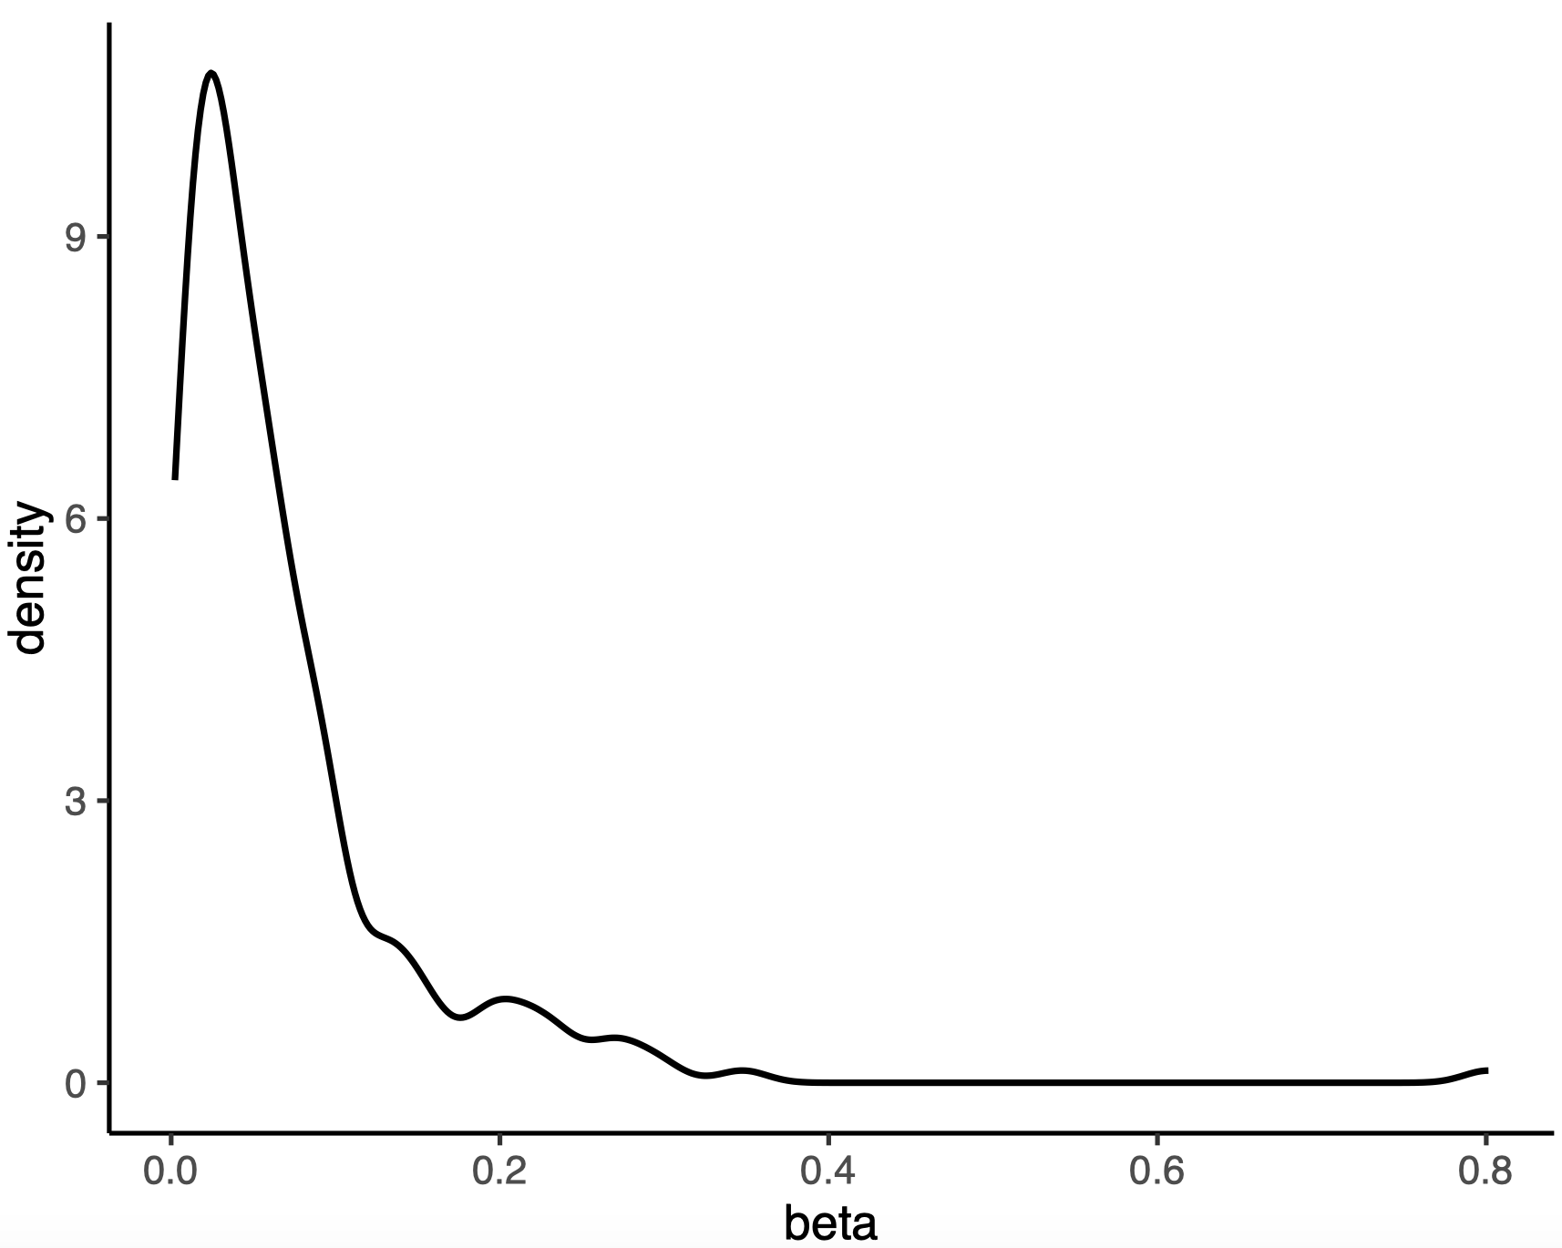

**Figure S7.** Methylation levels in our normal samples (Normal) and public datasets (WB, AD, and Cancer) for 209 hyper-methylated DMSs identified in LGA. (Left) Public datasets include 656 whole blood (WB) samples and 51 adenoma (AD) and 504 cancer samples. (Right) Density plot of DNA methylation levels (beta values) of 209 sites in all samples.



**Figure S6.** The DNA methylation level of *ADHFE1* promoter in the public datasets obtained from whole blood (WB), normal colorectal tissue (Normal), adenoma (AD) and cancer (Cancer).

*“4. The pathway analysis highlighted gut-brain-axis aroused a very interesting concept that the cross-talk between neuron system and GI system may be interrupted during carcinogenesis. Authors should provide other data (ie. immune staining of some key protein molecules in different tissue types) to strengthen their claims.”*

**Response:** Thank you for the suggestion. It is a great idea to provide immune staining data as support evidence. We feel deeply sorry that, the volumes of these benign lesions are quite limited with their diameters around 0.8 cm (**Table S6**), not like cancer samples. Methylation array requires a relatively large amount of input DNA after bisulfite treatment. It took about 1 and half years to screen for these treatment naïve subjects with adequate available tissue aliquots from out-patients. Nevertheless, it is a pity that almost all cases had no tissue samples left after microarray experiment. We will absolutely try to overcome these limitations in the future effort. In the revised manuscript, we include two studies showing the interaction of tumor and the nervous system in gastric cancer and liver cancer (PMID: 31647986, 29660379), and hopefully it will help to some extent.

*“5. The authors compared ADHFE1 with SEPT9, and found a better prediction power of ADHFE1 over SEPT9,* *authors should check if ADHFE1 is some way orthogonal to any of these FDA-approved biomarkers, including SEPT9 and carcino-embryonic antigen (CEA).”*

**Response:** This is a very good thought. Right now, only *SEPT9* was approved by FDA as the cfDNA diagnostic marker of colorectal cancer at DNA methylation level. We analyzed the correlation between *ADHFE1* and *SEPT9* as suggested by the reviewer. As shown in newly included **Figure S5**, the correlation of DNA methylation of these two genes was 0.77 (p-value <2.2e-16). As for the comparison with CEA, since CEA is not a routine test item for out patient adenoma clinic, we were unable to obtain data from the collaborating hospital or in public database.

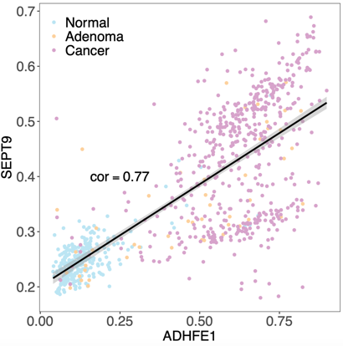

**Figure S5.** The correlation of methylation levels (beta value) between *ADHFE1* and *SEPT9* (Pearson correlation coefficient=0.77, p-value <2.2e-16).

*“6. One article published recently on* *Science Translation medicine describing the cfDNA methylation for early detection of colon cancer, authors should cite and discuss.”*

**Response:** Thank you for pointing out the reference from the STM study. In new version we have discussed the results described in reviewer suggested article, especially the methylation level change of cg10673833 found in that study. The methylation level of this site showed only a slight upward trend in tissues from normal to adenoma and cancer, in our samples as well as in public data. Therefore, most likely this cfDNA marker demonstrated good correlation for cancer development in blood samples but not the change from normal tissue to adenoma and cancer.

**Reviewer #2:** *Review of the manuscript”* ***Genome-wide DNA methylation profiles of Low- and High-grade adenoma reveals potential biomarker for early diagnosis of colorectal carcinoma****"*

**Overall response**: We thanks the reviewer’s positive comments. We found these points provide us an opportunity to make the manuscript more clear and solid in the method, results and discussion section. We believe we have addressed the reviewer’s comments and concerns in the revised manuscript. Our work actually have 3 parts including 1) generate genome-wide DNA methylation patterns for the early colon cancer DNA methylation 2) try to understand the pathway changes during the early cancer stage and 3) try to identify potential DNA methylation markers to indicate early cancer signals. We understand the importance of the cell-free DNA methylation based non-invasive diagnosis, especially the early diagnosis since it will significantly increase the overall survival time for the cancer patients and that’s why we proposed this study to discover the early methylation pattern for colon cancer with LGA and HGA samples and then to provide some diagnosis candidate markers for the further research. Furthermore, we demonstrated LGA and HGA provided an important proxy for early methylation biomarker identification and the gene could be a promising methylation biomarker for colorectal cancer. We agree with the reviewer we did not make solid validation to the markers we identified, however, we think our work still be interested for the readers especially for the clinical researcher to design a further independent validation to the candidate markers which actually require more samples and funding supports, especially considering these markers are early stage cancer biomarkers. Finally, identification of cancer-specific and tissue-specific methylation markers is the necessary and important step for cell-free DNA methylation diagnosis panel development and tissue-of-origin prediction. We want to make certain contribution to this field with our current study in which we spent quite long time to collect these treatment naïve early stage cancer samples.   
*“1. The reviewer thanks for the opportunity of this interesting manuscript, whose separate parts are of excellent, but the paper in all requires* *thorough emphasis and work together of the independent findings found in the present form of the manuscript. The title itself shows some* *contradiction that can be refound in the whole manuscript. The authors aimed identification of biomarkers of early diagnosis of colorectal carcinoma in tissue?”*

**Response:** We agreed it is more appropriate to say it as a detection method. We took the reviewer’s point, in this version, we changed title as “Genome-Wide DNA Methylation Profiles of Low- and High-Grade Adenoma Reveals A Potential Biomarker for Early Detection of Colorectal Carcinoma”.

*“2. The authors identified early adenoma markers, but they have not validated them, not tested in cell free DNA (liquid biopsy), either. The authors expanded findings from early, LGA adenoma to HGA and in silico, to publicly available cancers. The reviewers ask why? Cancer epigenetic data, markers are overwhelmingly available. Validated adenoma and cancer data are far less e.g.* *(Patai AV et al. Dig. Dis 2012,* *Patai AV et al. PLOS ONE 2015).”*

**Response:** Thank you for your suggestion. To our knowledge, our study is the first to provide genome-wide methylation profiles for adenoma with grading information. Adenoma is a relative benign lesion whose small volume make them difficult to provide adequate aliquot for research, and it took us one and half years to collect all the samples in this study. In the first two paragraphs of the results, we described the changes of methylation profiles across multiple stages, and tried to trace the earliest changes at methylation level in this precancerous lesion before tumor development. The comparison between adenoma and cancer samples showed that some methylation changes commonly observed in tumor could occur early in adenoma stage. For tissue biomarker identification, we feel sorry that we had to determine the candidates first in our datasets and try to validate them in public datasets. In the revised manuscript, we provide a new **Figure S7** illustrating their performance in public adenoma datasets without grading information. And we also have revised the abstract to emphasize our results at tissue level, and attempt to explain their potential application in liquid biopsy in the revised Discussion section. Considering the difficulties in obtaining this type of benign lesions, we hope our datasets will provide precious resources for researchers having interests on precancerous lesions. We apologize for lacking inclusion of certain papers especially for a related review. We discussed related results in revised version. In brief, for the ten genes validated in one study (*PLoS ONE*) were all hyper-methylated in our data, which to some extent is consistent with our results.

*“3. If the aim of the work is not the tissues diagnostics but more a liquid biopsy diagnosis based early diagnosis of cancer, the identified biomarker ADHFE1 should have been tested in cell free circulating DNA samples, as well.”*

**Response:** Thank you for your suggestion. Sorry for the confusion, and our aim is the detection of tumor development at tissue level and generate the DNA methylation dynamic changes in the early stage of the colon cancer. Perhaps inappropriate comparison between *ADHFE1* and *SEPT9* might cause this confusion. In the revised discussion, we have focused its better performance than *SEPT9* at tissue level and show its potential in liquid biopsy (a new **Figure S6**), which definitely requires cfDNA samples for validation in future efforts. We also deeply hope to gain the reviewer’s understanding on our limitations to afford a cohort at a satisfied sample size for liquid biopsy.

*“4. The authors compare the ADHFE1 marker to septin9, however SEPTIN 9 tissue sensitivity and specificity data (Toth et al.Pathol. Oncol. Res 2012,* *Toth K. et al Plos One 2012, and 2014) are not referred, rightly.”*

**Response:** We thank the reviewer to point out this missing of statement and we included related references accordingly.

*“5. The authors have identified 209 hypermethylated positions in their one data, in LGA cases. These markers were found further methylated in HGA (authors' own data) and 504 publicly available cases. The authors do not describe the correlation of their finding to publicly available LGA or HGA or adenoma (50 are available according to their materials and methods section) specimen. This would be especially necessary as no validation is done in this study, at all. The list of the identified markers are not available in the manuscript and in any addendum which is major lack of the manuscript.”*

**Response:** We thank the reviewer’s suggestion and a heatmap from adenoma comparison between 51 adenoma samples in public database (a new **Table S7** and revised Method section) and ours was included as **Figure S2** in new version, and as expected, AD samples of public database also exhibited hyper-methylation maintenance or enhancement.

The lack of information for the 209 hyper-methylated sites was our oversight and thank you for pointing it out, we have provided in **Table S1**.



**Figure S2.** Methylation levels of 209 hyper-methylated DMSs in our datasets (Normal, LGA, HGA), 51 public adenoma datasets (AD) and 504 public datasets cancer (Cancer). AD, Adenoma; HGA, High grade adenoma; LGA, Low grade adenoma.

*“6. The publicly available 51 adenoma samples are not used and compared to own LGA or HGA results. The authors do not perform wet-lab verification, either. These are the two major missing of the study! In case of revision these missings should be included, as well.”*

**Response:** For the first missing part, we included suggested comparing result in revised text (**Figure S7**). For the wet lab part, as also pointed out in reply 4 to reviewer 2, we have to say sorry again. The volumes of these begins lesion are quite limited, and It is a pity that almost all cases had no tissue samples left after microarray experiment. We hope the reviewer forgive our current limitations, and we will absolutely try to overcome the limited sample volume in benign lesions in future design.

*“7. The authors do not document their findings and do not describe their biomarkers except the AHFE1, and ACSS3.**”*

**Response:** In our revised version we included a list the 209 hyper-methylated sites in **Table S1**. Our current results only support *ADHFE1* as a candidate biomarker therefore we focused on this factor only in the manuscript.

*“8. Without these and without the publication of their results on GSE or other available public site, authors should and could not use other researchers' results. This paper could not be accepted and published!”*

**Response:** We totally agree and have provided a detail list of public datasets used in the study (**Table S7**). The GEO accession number of our datasets is GSE139404, and it will be immediately available upon publication.

*“9. An overall hypomethylation was found. 440 in LGAs and 805 in HGAs. The reviewer would ask how many hypermethylated sites were identified in HGA-s? How many were in overlap? The Venn diagram does not clear explanation on this in the Figure 1.”*

**Response:** As the reviewer asked, we included two Venn plots as **Figure S1** to demonstrate hypo- and hyper-methylated sites. Compared with the Normal, LGA had 209 hyper-methylated DMSs and 441 hypo-methylated DMSs. And HGA had 8,692 hyper-methylated DMSs and 13,726 hypo-methylated DMSs. Compared with LGA, there were 1367 hyper-methylated DMS and 126 hypo-methylated DMS in HGA.

The Venn in Figure 1 showed numbers of the genes, not numbers of the sites.

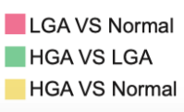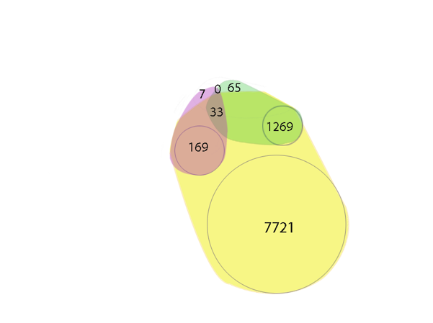 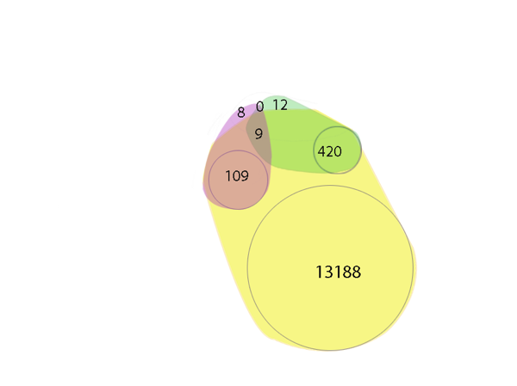

hyper hypo

**Figure S1.**  Hyper DMSs (Left) and hypo DMSs (Right) shared between HGA (High grade adenoma), LGA (Low grade adenoma) and Normal groups or specific to each group.

*“10. The section” Landscape of DNA methylation of pre-cancerous benign lesions" is not systematic.* *The Figure 1 is just increasing this inconsistency. The authors evaluated in silico data without detailed publication of the findings in their paper (tables, top genes, sites etc.) Here arise again the question early adenoma markers were used for adenoma detection but and why for cancer?”*

**Response:** As mentioned above (reply 2), using adenoma tissues may lead us to discover the early marker for cancer diagnosis. A classic model of colorectal cancer development is from normal intestinal epithelial tissue to low-grade adenoma, then into high-grade adenoma, and finally into cancer. The methylation changes we observed in low-grade adenoma were enhanced or maintained in high-grade adenoma, which is consistent with the pattern of colorectal cancer progression. As a precancerous stage, we look for markers of adenoma not just to detect adenoma, but to provide a possible early window for cancer detection.

*“11. The section " Hyper-methylated CpG sites exhibited better* *discriminatory performance between normal, pre-cancerous, and cancerous tissues than the hypo-methylated pattern for CRC" relates to publicly available 278 normal, 51, adenoma, and 504 cancer samples. In this section the authors perform in silico evaluation of these data but do not relate them to their own data. The reviewer asks why?  
In any case, authors should validate the identified in silico markers in their own data, for cancer or early diagnosis for cancer or for adenomas.”*

**Response:** Since our sample size is limited, we adopted a strategy to use our data as the training set and then to take the public data as the validating set. We believe this may allow the maximum statistical effectiveness.

*“12. The identified marker set is also not detailed and unavailable for the reviewer and for any reader. This is unright and unacceptable.”*

**Response:** We apologize for the oversight in the earlier version of the manuscript. We have now provided Table S1 for detailed information of all candidate sites.

*“13. The section 4, " the promoter of ADHFE1 may be a potential biomarker for colorectal adenoma and cancer" describes two biomarker the ADHFE1 and ACSS1. The validation of these two, LGA marker was done in silico on the publicly available data sets from GEO and Array Express.  Validation should be done by other methods, as well.  Expression analysis of mRNA or proteins from these markers should also contribute to validation.”*

**Response:** We thank reviewer’s suggestion. In the manuscript, we have used TCGA data to validate the relationship between promoter methylation and transcription level of *ADHFE1* and ACSS3, resulting a negative correlation as expected as shown in **Figure 4**.